Isolating Symbionts from Live Host Tissue

Rachel Wright [rwright@smith.edu](mailto:rwright@smith.edu)

4 June 2019

# A. Initial Isolation

1. Use a razor blade to remove a small (<=1cm2) piece of symbiotic host tissue and transfer it to a petri dish.

*Avoid host tissue regions with obvious algal growth.*

1. Briefly chop the tissue with the razor.
2. Add 1 mL sterile artificial seawater (AWS) to the petri dish and backpipet a few times to homogenize.
3. Transfer the tissue/ASW “slurry” to a microcentrifuge tube.

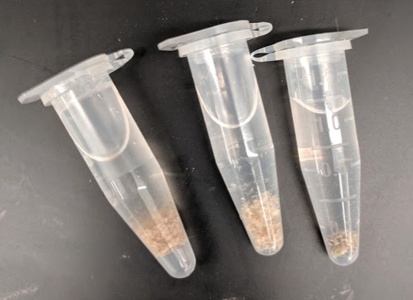

1. Add a small amount (½ spatula) of glass beads to the microcentrifuge tube.
2. Vortex the microcentrifuge tube for 1 minute.
3. Centrifuge the tube at max speed (16.5 xg) for 30 seconds.

*The beads and any skeletal fragments that may have been included in the tissue homogenate should sediment to the bottom of the tube. The supernatant may appear brown.*

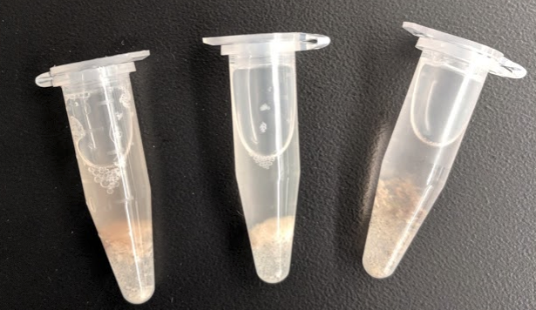

1. Add 4 mL of [f/2 + GeO2 media](https://docs.google.com/document/d/1sxf1fA_IX3RjEA1pV9t-AKUDnoYbNkuys38kA3MjNFk/edit#heading=h.lvuy4w26aklz) to each well of a 6-well plate.
2. Add 100 µL of supernatant to each well of the 6-well plate.

*Avoid any debris, which may include suspended filamentous algae if it was growing on the tissue.*

1. Observe the wells using an inverted microscope.

*You may only see a few clumps of Symbiodiniaceae cells (below), depending on how many symbionts were in the original slurry.*

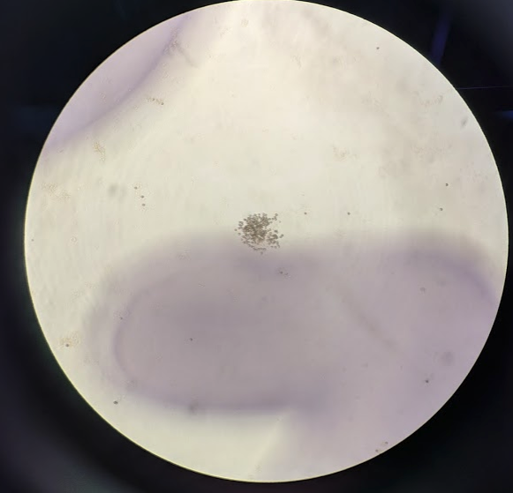

*If your cultures are very dense at this stage and your goal is to culture an isogenic strain from a single cell, you may want to perform a few serial dilutions to reduce the density.*

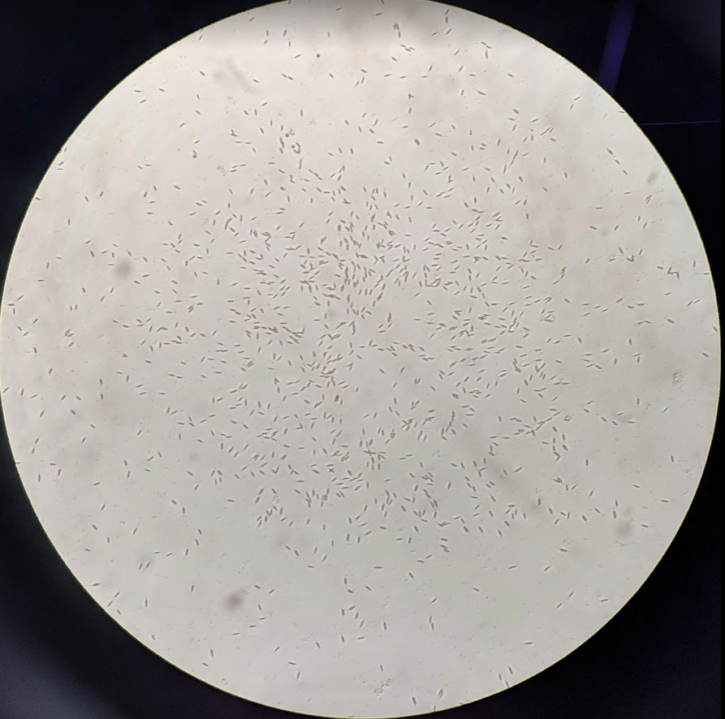

*You may see a lot of diatoms (above). These are the devil.*

1. Transfer the 6-well plates to an incubator set to the temperature and light conditions appropriate for your strain.

*Remember, symbionts in a dense culture or within the host tissue “self-shade.” The same light intensity that is appropriate for a dense culture or symbiotic host tissue may be too bright. Consider starting at a lower light intensity or shading the plates until the cultures grow to higher densities.*

# B. Isolating single cells for isogenic cultures

1. Add 1 mL [f/2 + GeO2 media](https://docs.google.com/document/d/1sxf1fA_IX3RjEA1pV9t-AKUDnoYbNkuys38kA3MjNFk/edit#heading=h.lvuy4w26aklz) to each well of a 48-well plate.
2. Using a pipet tip, isolate single cells from the wells of the 6-well plate and transfer them to a fresh well in the 48-well plate.

*Strategies:*

* 1. *Find or create an area in the well that only has a single cell (or clump of cells, if unavoidable). Aspirate a small volume of liquid from that region and transfer to the new well.*
  2. *Find or create an area in the well that only has a single cell (or clump of cells, if unavoidable). Scrape the cell with your pipet tip and swirl the pipet tip in the new well.*

1. Transfer the 48-well plate to an incubator set to the temperature and light conditions appropriate for your strain.

*Remember, symbionts in a dense culture or within the host tissue “self-shade.” The same light intensity that is appropriate for a dense culture or symbiotic host tissue may be too bright. Consider starting at a lower light intensity or shading the plates until the cultures grow to higher densities.*

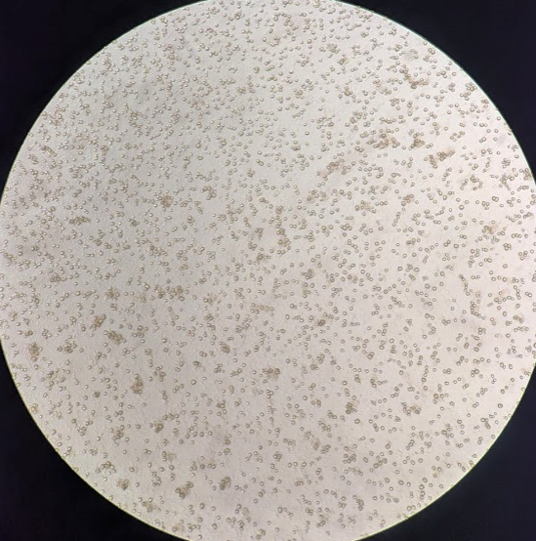

*Be patient with growth. It may take a couple of weeks to notice anything. Hopefully soon you will have wells full of clean symbiont cultures.*